**Design Header**

Functionality of the towers

**Sub-Features**

• Attacking

• Battery swapping

• Battery Recharging

**Essence Statement/Logline**

Towers will attack/be attacked as enemy units walk by so towers are able to deal with damage by changing batteries.

**The Player's Story**

The towers are all battery operated toys. But they drain their batteries when enemies get close so the player needs to switch/recharge the batteries of towers that are in combat more often. If a tower’s battery is dead it is disabled and can’t attack enemies but the tower is not destroyed.

**Anti-Vision**

* Towers can’t be placed on the path. Towers can only be placed on the sides of the path
* Towers are not placed freely, they are restricted my a grid system
* Towers are not damaged; repaired or destroyed, their health points (batteries) are switched and regenerated

**Reference Material**

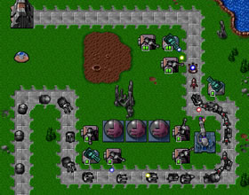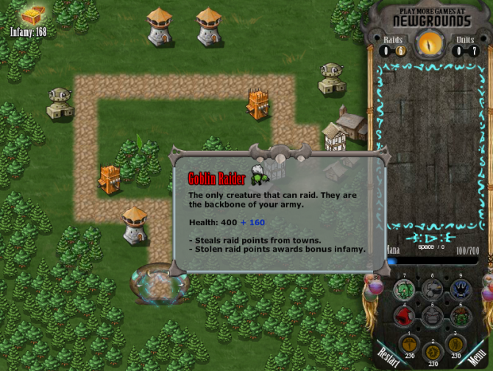

**Controls**

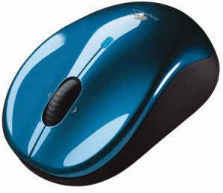Left click on objects and locations to make selections.

**Objectives and Requirements – MINIMUM**

* Tower build menu side bar
* Standard towers
* Support towers
* Splash towers
* Battery life will be displayed above the tower in a health bar
* Battery life will diminish when a tower is attacked
* Players will be able to swap tower batteries in between waves
* A battery charger will be in the bottom of the Tower build menu side bar
* Batteries can be placed on the charger in between waves
* Batteries on the charger will charge during waves

**Design Behaviour: What the Player Sees and Hears**

**Behavior**

*Building a tower*

* Left clicking a tower in the build menu will bring up a construction icon
* With the construction icon, selecting a space on the grid will build the chosen tower in that area

*Changing a battery*

* Left clicking on a built tower will bring up a battery icon
* With the battery icon, left clicking a tower will swap batteries
* With the battery icon, left clicking a the charger will put the battery on to charge
* With the battery icon, left clicking anywhere that isn’t a tower or charger will cancel the battery icon

*Tower Attacks*

* Standard range towers shoot at single enemy units
* Support towers fire at single enemies and slow them down when hit
* Splash towers launch objects which hit multiple enemies when they explode

**What the Player Sees**

Initially the player will see the map and the side bar menu with different tower types as well as a battery charger at the bottom of the side bar.

*Building a tower*

* Left clicking a tower in the build menu will turn the mouse cursor into a hand holding a toy building
* When a placement is selected the mouse cursor changes back and the tower falls from the sky and lands on the selected location
* Health bars decrease as enemies attack

*Changing a battery*

* Left clicking on a built tower will turn the mouse cursor into a hand holding a battery
* If another tower is selected the mouse cursor changes back and the health bars switch places instantly
* If the charger is selected the mouse cursor changes back and a battery appears in the charger with a health bar above that fills up during a wave

*Tower Attacks*

* Standard towers shoot marbles at enemy units
* Support towers have a slow firing rate but towers fire gum bubbles which pop and cover enemies
* Splash towers have the slowest firing rate but launch water balloons that splash and hit multiple enemies when they explode

**What the Player Hears**

* Whistling noise heard while tower is falling followed by a boom when it lands
* A two clicks are heard when the player swaps batteries
* A beep is heard when a battery is placed on the charger
* A powering down noise when a tower runs out of power
* Splash noise when water balloon hits
* Thud noise when marbles hit
* Popping noise when gum bubbles hit

**FX**

* Splash FX
* Landing dust FX
* Electricity FX when tower is recharged

**HUD**

* Side bar menu
* Battery charger

**AUDIO**

* Audio tower dropping
* Audio tower impact
* Audio battery switch
* Audio battery into charger
* Audio power down
* Audio splash
* Audio pop
* Audio “thud” enemy hit

**Rough Estimates**

**Engineering**

This is a prioritized list of engineering tasks to complete the Minimum phase. You’ll need to submit your design to the Lead Engineer since a rough estimate is needed and is expected to be refined and updated once the feature is broken down into system oriented tasks. Confidence is your percentage of confidence that you can hit a date based on your estimate. As you don’t have access to a Lead Engineer ☺ don’t worry about this section.

**Content**

This is a prioritized list of content required to complete the Minimum phase. The Lead Artist needs to vet your design since a rough estimate is needed and is expected to be refined and updated once the feature is broken down into system oriented tasks. Confidence is your percentage of confidence that you can hit a date based on your estimate. As you’re not working with a Lead Artist, skip this section also.

**Design**

This is a prioritized list of content required to complete the Minimum phase. The Lead Designer will vet your design since a rough estimate is needed and is expected to be refined and updated once the feature is broken down into system oriented tasks. Confidence is your percentage of confidence that you can hit a date based on your estimate. You’re the lead designer, so you’re responsible for prioritizing implementation and listing it here. A good producer can help you with this.

**Objectives and Requirements - SHIPPING**

* Info windows on mouse hover
* Tower type D.O.T. – Damage Over Time
* Tower type Aura
* Battery charger slot increases
* Battery charge upgrades
* More charge health, take less damage
* Tower class upgrades
* Basic tower – longer range, more damage, shoot through enemies (possibly hitting more)
* Support towers – longer range, slow enemies more, weaken enemy defence
* Splash towers – longer range, more damage, knock-back damage
* D.O.T. towers – longer range, more damage, longer duration
* Aura towers – wider aura, more damage, increased armor aura

**Design Behaviour: What the Player Sees and Hears**

**Behavior**

*Upgrading a tower*

* Left clicking a tower on the field will open a small upgrade menu
* Left clicking an upgrade will give the tower the appropriate upgrade and close the menu

*Mouse hover*

* Hovering the mouse over any button/icon for a few seconds will make a window pop up which gives a brief description of what the button/icon will do/make

*Upgrading a battery*

* Battery upgrades will be given automatically upon world completions

*Tower Attacks*

* D.O.T. towers attack single enemies but the damage is dealt over time
* Aura towers do area damage every few seconds in waves

**What the Player Sees**

*Mouse hover*

* The mouse hover info screen fades in after hovering over an object for a few seconds and fades out after a the button is selected or the mouse leaves the button/icon

*Charger slot increase*

* On world completion a note and an image will pop up telling the player that they have unlocked a bigger battery charger or a battery health upgrade
* The charger image will be replaced with a larger battery charger with more slots

*Tower Attacks*

* D.O.T. towers shoot bees at enemies, enemies that are hit will glow green while infected
* Aura towers will send out electrical waves in all directions

**What the Player Hears**

* Congratulating sound when player unlocks a battery upgrade
* Buzzing sound when bee spawns

**FX**

* Particle fx when a battery upgrade is unlocked
* Glowing fx when enemies are infected

**HUD**

* Side bar menu

**AUDIO**

* Audio congratulation sound

**Objectives and Requirements - STRETCH**

Support

* Blinding
* Teleporting
* Confusion